NBA TEAMS & PLAYER PERFORMANCE ANALYSIS

WIREFRAME DOCUMENT

Shridatta Patil

Homepage

Dashboard homepage consists of single page having navigation icon to go on. The page designed in such way that user can switch between Home page and sections. There are 2 different sections in the home page where the user can switch according to requirement.

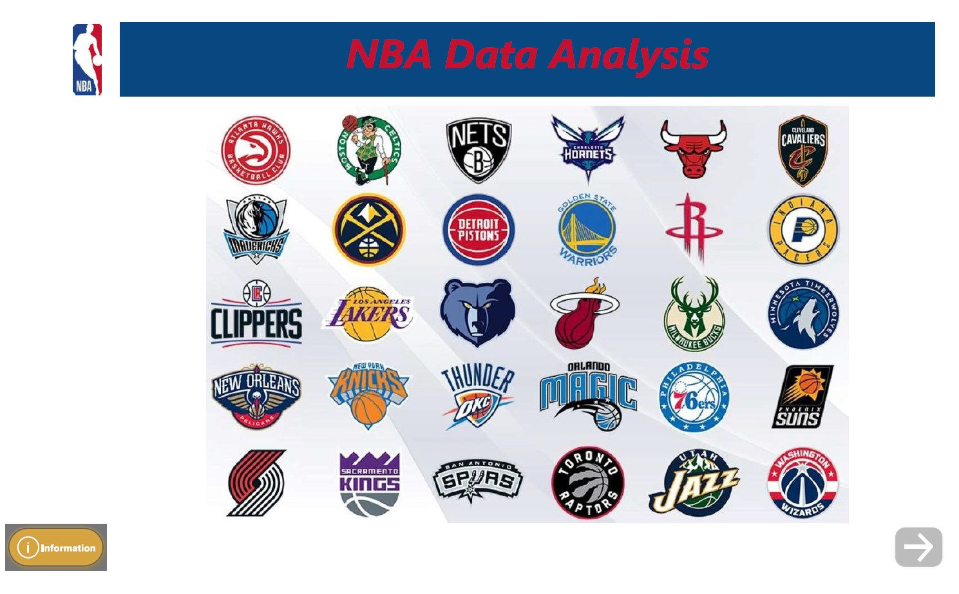

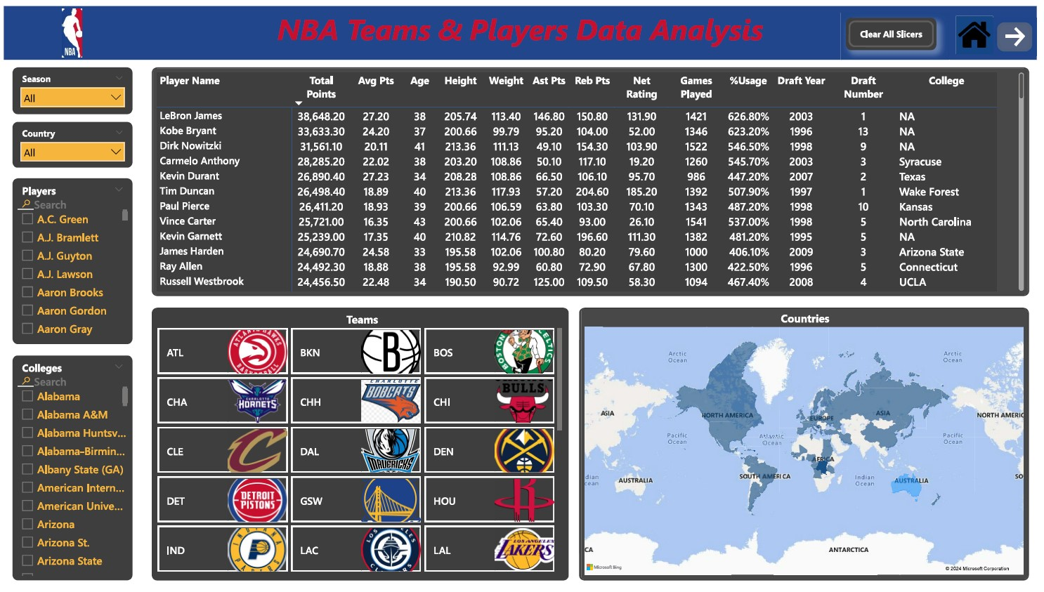

The overall teams, season and players of that team’s analysis is available in this page.

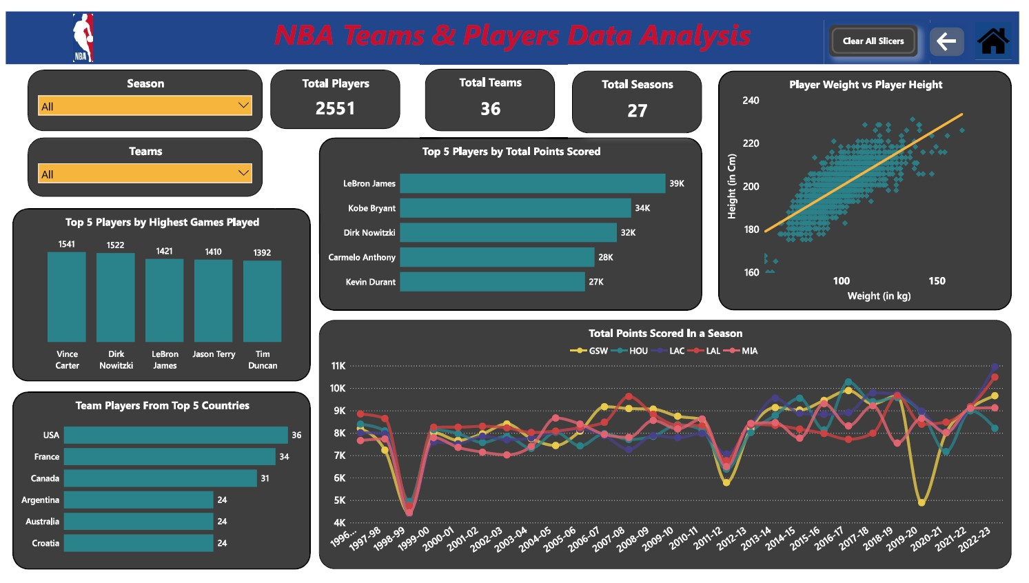

In this page the top scoring players, teams and countries from which highest number of players are playing in NBA.